Obtuse Angle
# Source: AI Source: Provided by: [Data Path: Persons Table -> ID Column: 1, Name_En Column: Motasem Essam] -> From: [ChatGPT] on [7/25/2026]
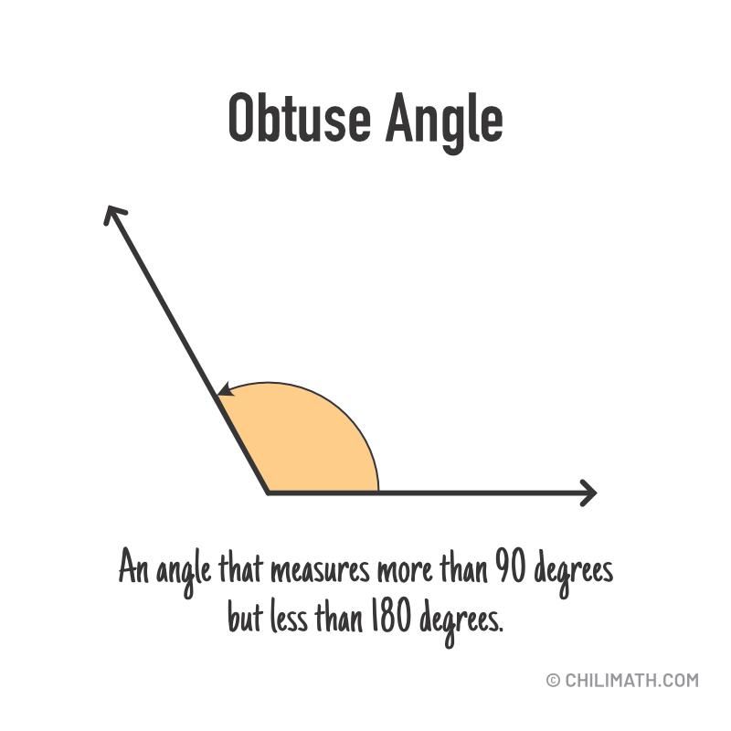
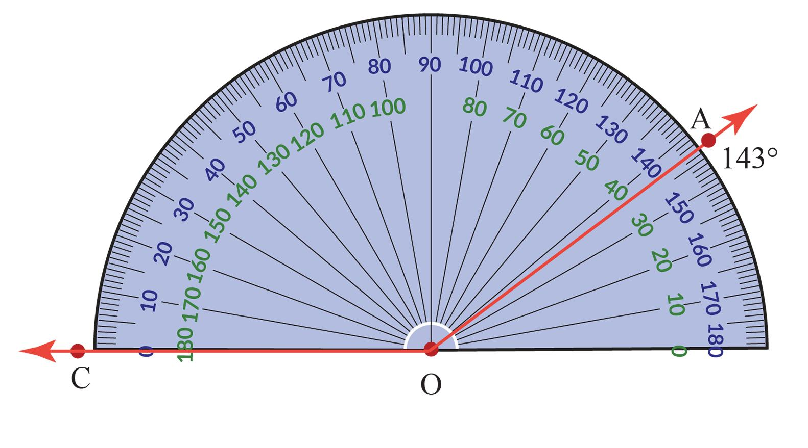
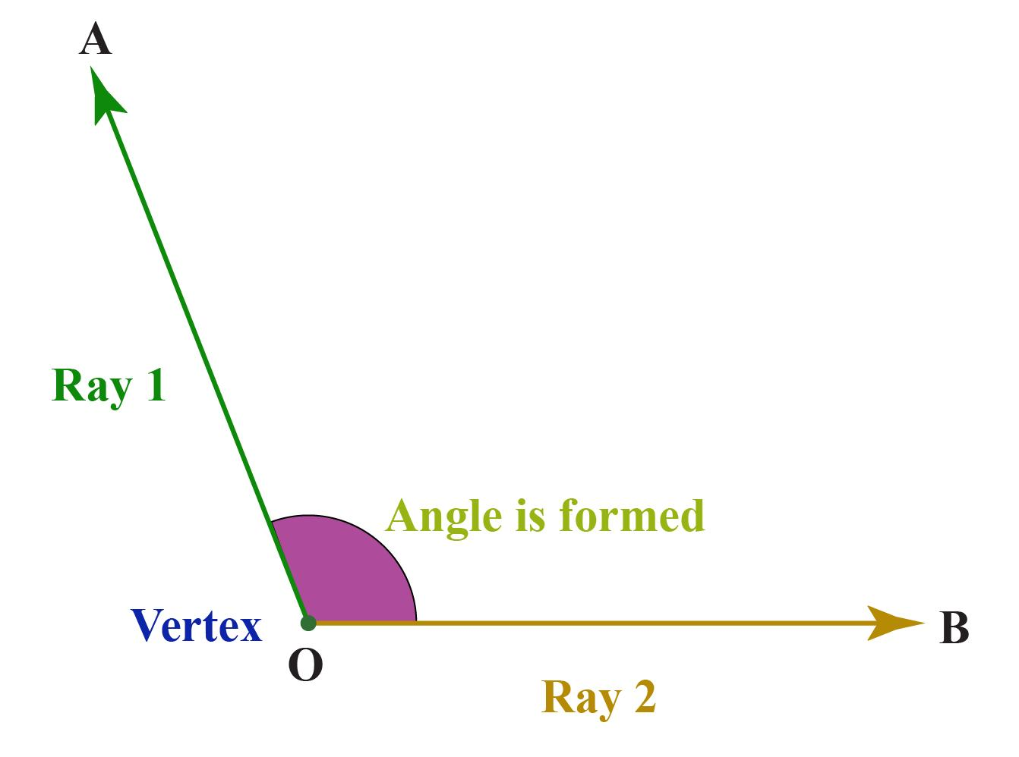
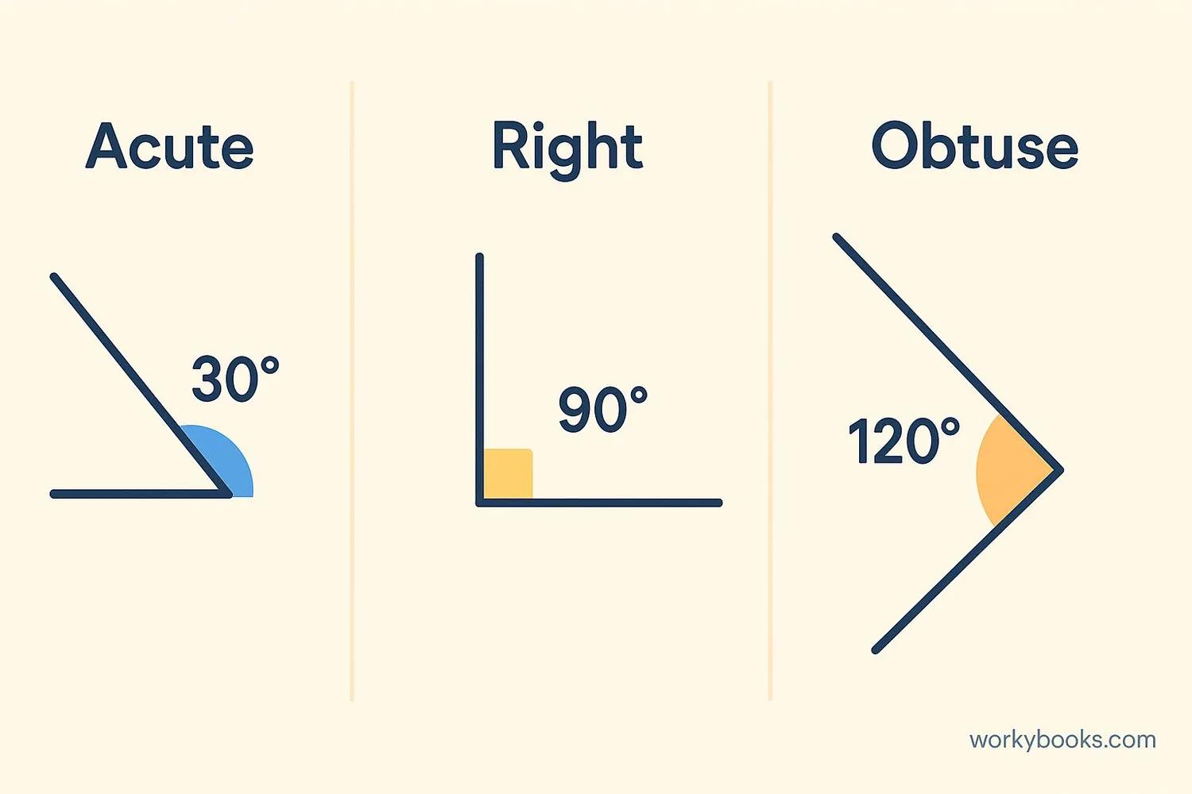
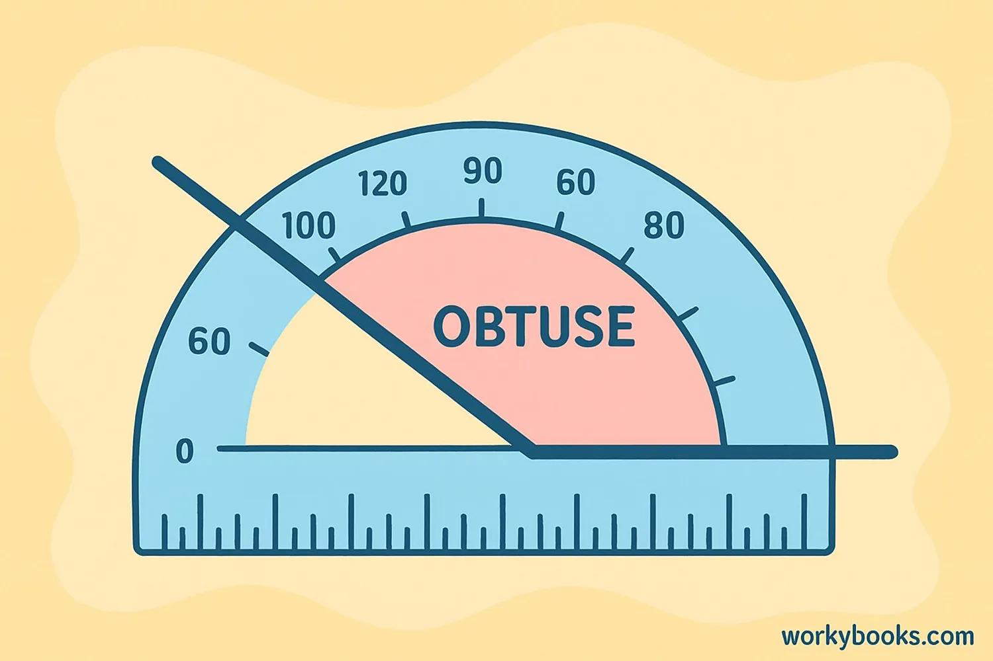
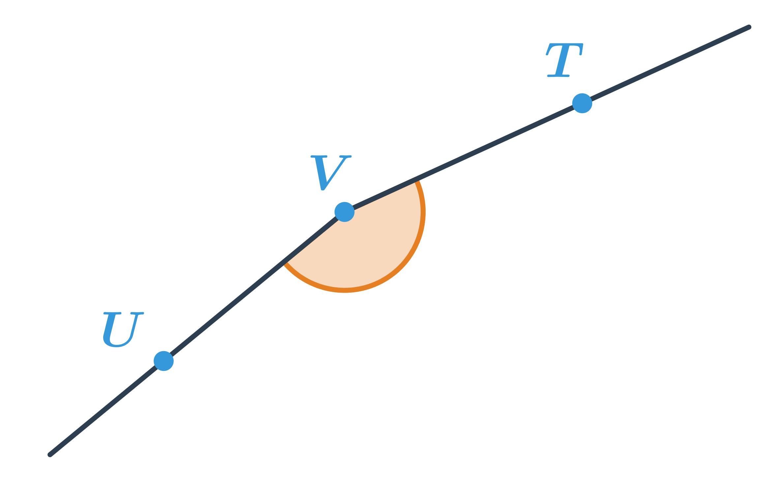

Definition
# Source: AI Source: Provided by: [Data Path: Persons Table -> ID Column: 1, Name_En Column: Motasem Essam] -> From: [ChatGPT] on [7/25/2026]
An Obtuse Angle is an angle whose measure is greater than ${90}^{∘}$but less than ${180}^{∘}$. It is larger than a right angle but smaller than a straight angle.

Characteristics
# Source: AI Source: Provided by: [Data Path: Persons Table -> ID Column: 1, Name_En Column: Motasem Essam] -> From: [ChatGPT] on [7/25/2026]
An obtuse angle:
- Measures more than ${90}^{∘}$.
- Measures less than ${180}^{∘}$.
- Is larger than a right angle.
- Is formed by two rays sharing a common vertex.
- Can be measured in degrees or radians.

Illustration
# Source: AI Source: Provided by: [Data Path: Persons Table -> ID Column: 1, Name_En Column: Motasem Essam] -> From: [ChatGPT] on [7/25/2026]
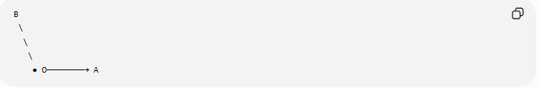
B
\
\
\
● O────────→ A
The opening between the rays is greater than ${90}^{∘}$but less than ${180}^{∘}$.

Mathematical Representation
# Source: AI Source: Provided by: [Data Path: Persons Table -> ID Column: 1, Name_En Column: Motasem Essam] -> From: [ChatGPT] on [7/25/2026]
An obtuse angle satisfies:
$${90}^{∘}<θ<{180}^{∘}$$
or, in radians,
$$\frac{π}{2}<θ<π$$

Examples
# Source: AI Source: Provided by: [Data Path: Persons Table -> ID Column: 1, Name_En Column: Motasem Essam] -> From: [ChatGPT] on [7/25/2026]
Common examples include:
$${100}^{∘} \\ {120}^{∘} \\ {135}^{∘} \\ {150}^{∘} \\ {175}^{∘}$$

Coordinate Geometry
# Source: AI Source: Provided by: [Data Path: Persons Table -> ID Column: 1, Name_En Column: Motasem Essam] -> From: [ChatGPT] on [7/25/2026]
Suppose two rays originate from
$$O\left(0 , 0\right)$$
First ray passes through
$$A\left(5 , 0\right)$$
Second ray passes through
$$B\left(- , 23\right)$$
The angle
$$∠AOB$$
is greater than
$${90}^{∘}$$
and less than
$${180}^{∘}$$
therefore it is an obtuse angle.

Real-World Examples
# Source: AI Source: Provided by: [Data Path: Persons Table -> ID Column: 1, Name_En Column: Motasem Essam] -> From: [ChatGPT] on [7/25/2026]
Obtuse angles appear in:
- A door opened wider than ${90}^{∘}$.
- Clock hands at approximately 4:00.
- A reclining chair.
- A wide-open pair of scissors.
- The corner formed by some road intersections.

Properties
# Source: AI Source: Provided by: [Data Path: Persons Table -> ID Column: 1, Name_En Column: Motasem Essam] -> From: [ChatGPT] on [7/25/2026]
An obtuse angle:
- Measures greater than ${90}^{∘}$.
- Measures less than ${180}^{∘}$.
- Is larger than a right angle.
- Is smaller than a straight angle.
- Cannot exist more than once in a triangle.

Obtuse Angles in Triangles
# Source: AI Source: Provided by: [Data Path: Persons Table -> ID Column: 1, Name_En Column: Motasem Essam] -> From: [ChatGPT] on [7/25/2026]
An obtuse triangle contains:
- One obtuse angle
- Two acute angles
A triangle cannot have more than one obtuse angle because the sum of the interior angles of a triangle is:
$${180}^{∘}$$

Applications
# Source: AI Source: Provided by: [Data Path: Persons Table -> ID Column: 1, Name_En Column: Motasem Essam] -> From: [ChatGPT] on [7/25/2026]
Obtuse angles are used in:
- Plane Geometry
- Coordinate Geometry
- Trigonometry
- Engineering
- Architecture
- Construction
- Surveying
- CAD (Computer-Aided Design)
- Robotics
- Computer Graphics

Advantages
# Source: AI Source: Provided by: [Data Path: Persons Table -> ID Column: 1, Name_En Column: Motasem Essam] -> From: [ChatGPT] on [7/25/2026]
Studying obtuse angles helps to:
- Classify geometric figures.
- Analyze triangles.
- Solve geometric proofs.
- Understand trigonometric relationships.
- Design inclined structures.

Limitations
# Source: AI Source: Provided by: [Data Path: Persons Table -> ID Column: 1, Name_En Column: Motasem Essam] -> From: [ChatGPT] on [7/25/2026]
An obtuse angle:
- Cannot equal
$${90}^{∘}$$
- Cannot equal
$${180}^{∘}$$

Comparison with Other Types of Angles
# Source: AI Source: Provided by: [Data Path: Persons Table -> ID Column: 1, Name_En Column: Motasem Essam] -> From: [ChatGPT] on [7/25/2026]
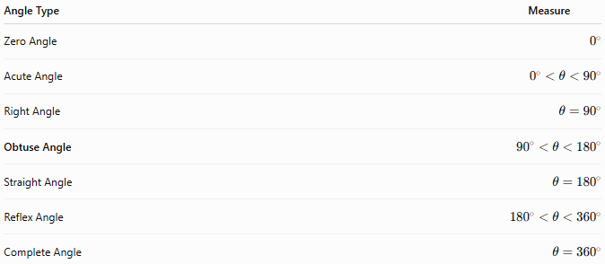
Angle Type | Measure
Zero Angle | $$0^{∘}$$
Acute Angle | $$0^{∘}<θ<{90}^{∘}$$
Right Angle | $$θ={90}^{∘}$$
Obtuse Angle | $${90}^{∘}<θ<{180}^{∘}$$
Straight Angle | $$θ={180}^{∘}$$
Reflex Angle | $${180}^{∘}<θ<{360}^{∘}$$
Complete Angle | $$θ={360}^{∘}$$

Key Points
# Source: AI Source: Provided by: [Data Path: Persons Table -> ID Column: 1, Name_En Column: Motasem Essam] -> From: [ChatGPT] on [7/25/2026]
- An Obtuse Angle measures:
$${90}^{∘}<θ<{180}^{∘}$$
- In radians:
$$\frac{π}{2}<θ<π$$
- It is larger than a right angle but smaller than a straight angle.
- An obtuse triangle contains exactly one obtuse angle.
- Obtuse angles are fundamental in geometry, trigonometry, engineering, architecture, surveying, CAD, robotics, and computer graphics.

Conclusion
# Source: AI Source: Provided by: [Data Path: Persons Table -> ID Column: 1, Name_En Column: Motasem Essam] -> From: [ChatGPT] on [7/25/2026]
An Obtuse Angle is an angle measuring greater than ${90}^{∘}$and less than ${180}^{∘}$, making it wider than a right angle but not large enough to form a straight line. It commonly appears in geometric figures such as obtuse triangles and in many real-world structures with wide openings or inclined designs. Obtuse angles are fundamental in plane geometry, coordinate geometry, trigonometry, engineering, architecture, construction, surveying, CAD, robotics, and computer graphics, where they are essential for analyzing shapes, orientations, and structural relationships.

